Middle Ages

Feudal System
Small communities are formed around the local lord and the manor. The lord owns the land and everything in it.
The Manor
The center of life in the Middle Ages is the manor. The local lord lives in a large house or castle. A small village is around the castle.

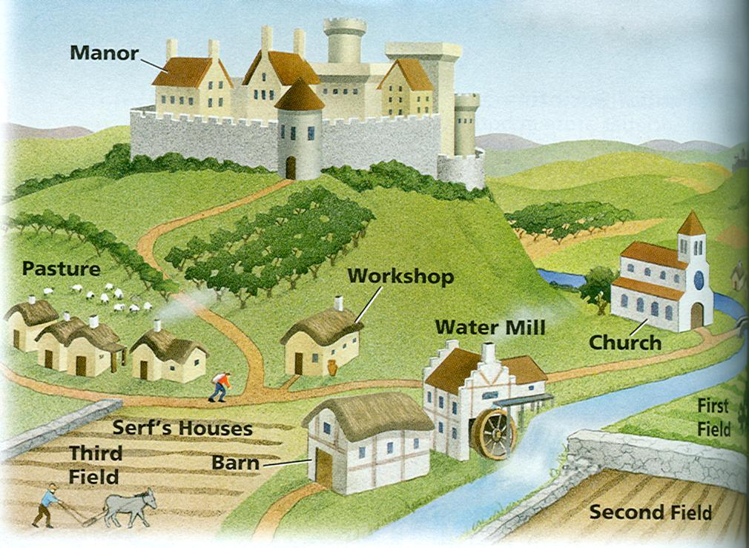
or Castle
C

Hierarchy of Rulers
King - The top leader in the land is the king. The king divides it up among the Nobles. In return, the Nobles gives their loyalty and soldiers to the king..
Bishop - The Bishop is the top church leader.
Baron - Barons ruled large areas of land called fiefs. They reported directly to the king and were very powerful. They divided up their land among Lords who ran individual manors. Their job was to maintain an army that was at the king's service. If they did not have an army, sometimes they would pay the king a tax instead. This tax was called shield money.
Lord - The lords ran the local manors. They also were the knights and could be called into battle at any moment by their Baron. The lords owned everything on their land including the peasants, crops, and village.
Peasants or Serfs
Most of the people living in the Middle Ages were peasants. They had a hard rough life. Some peasants were considered free and could own their own businesses like carpenters, bakers, and blacksmiths. Others were more like slaves. They owned nothing and were pledged to their local lord. They worked long days, 6 days a week, and often barely had enough food to survive.
